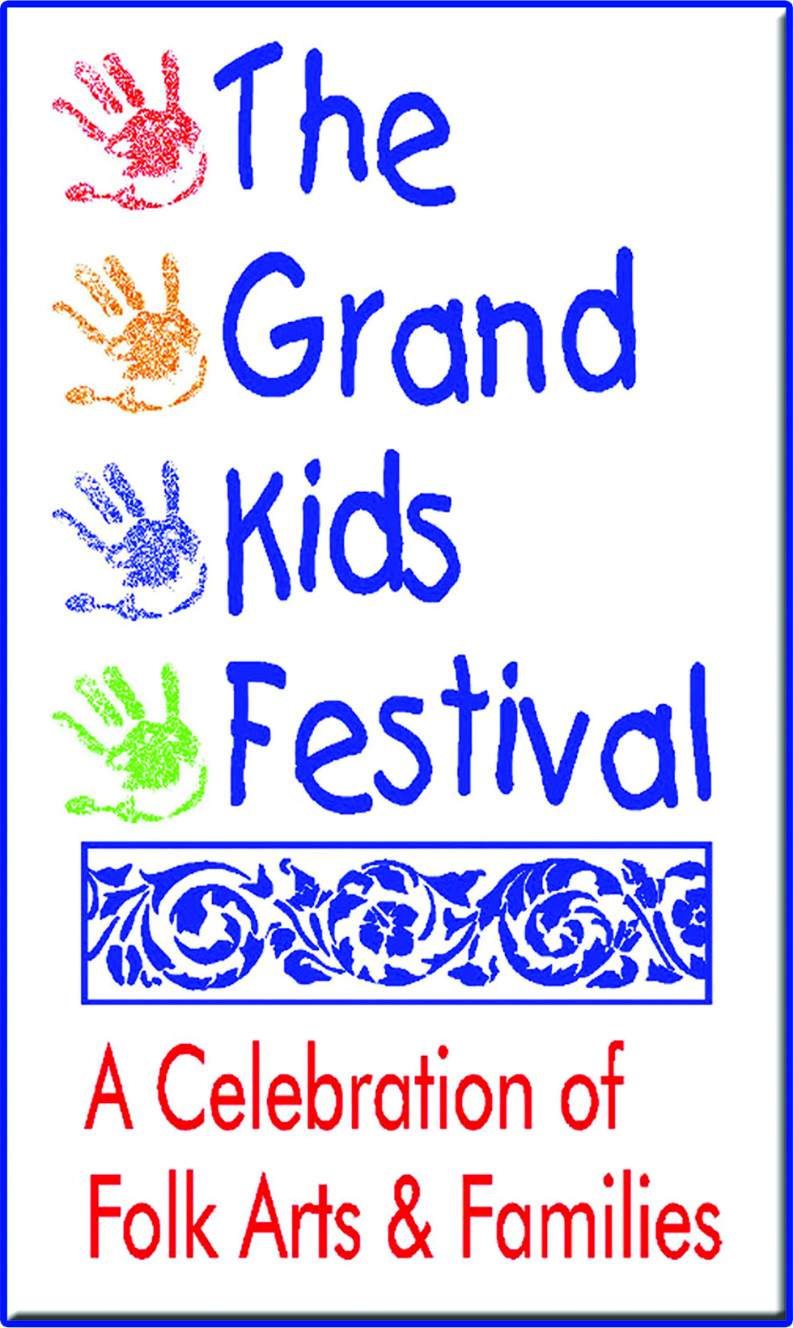
Chalk It Up! Western Style
Street Art Competition

Entry Deadline: Monday, April 25, 2022

Eligibility:
All Galveston County Public, Private & Homeschooled High School students are invited to participate in the Chalk It Up Western Style! Street Art Competition.
Art Teachers from all schools are encouraged to register teams of two students or individual students.

The following Awards will be presented to top 3 winning teams or individual students:
1st Place Team $200 • 2nd Place Team $100 • 3rd Place Team $50

2 Ways To Participate In 2022:
We want to make sure that all schools have an opportunity to participate.
- We have a total of 10 spaces for individual students or teams of two participating virtually and 10 spaces for individual students or teams of two participating at the festival - see next page for details.
  - Complete a chalk piece (3ft x 3ft square) at School during school hours supervised by art teacher, prior to The Grand Kids Festival. Completion and submittal no later than Friday, April 22, 2022.
  - Complete a chalk piece (3ft x 3ft square) at The Grand Kids Festival on Saturday, April 30, 2022 with Social Distancing Measures in place. Must register no later than Friday, April 22, 2022.

Chalk It Up! Application Process:
- Submit a Registration Form for each individual student or 2 student team indicating the way you would like to participate
  - Completed at School
  - Completed at The Grand Kids Festival

Deadline to submit is Friday, April 22, 2022. Only the first 10 individuals or teams registered in each category will be able to participate.

Confirmation of Team Status will be sent via email upon receipt of application.

Theme: Western
Subject matter to be determined by individual or team
Use this to your creative advantage!
The criteria for judging will be:
Impact • Feeling/Mood • Presentation • Neatness
Creativity/Originality • Effort/Care • Team Cooperation
Registration Forms are available at
www.grandkidsfestival.com under Participation tab Chalk It Up Island Style!
Choose your participation preference – 10 teams each via school or in person at the event

Completed at School
Entry Deadline: Friday, April 22, 2022
- Teams must complete their pieces in no more than 3 hours at school
- All materials to be picked up at The Grand 1894 Opera House Office on Friday, April 1, 2022 from 2:30pm-5:00pm.
- School participants Artwork must be delivered to The Grand on Friday, April 22, 2022 between 1:00pm-5:00pm.
- The Grand Kids Festival will photograph these entries and place on The Grand Kids Festival Facebook Page. https://www.facebook.com/TheGrandKidsFestival

Completed at The Grand Kids Festival
Entry Deadline: Saturday, April 30, 2022, if space is available
- Teams or individuals must complete their piece on Saturday, April 30, 2022 between 10:00am and 1:00pm and upload their photo immediately following the completion of the event.
- Teams that have 2 students must follow all social distancing rules.

Applies to All Teams
- Students are encouraged to watch instructional videos on YouTube and similar websites to refine their chalk painting skills.
- Student artist teams will create a chalk street painting measuring 3ft x 3ft on a piece of roofing paper that will be provided by The Grand Kids Festival.
- Teams will be provided one box of assorted pastel chalk, tape measure, chalkboard erasers, hairspray, wet wipes, latex gloves, container for chalk, and 3ft x 3ft piece of roofing paper.
- Judging of all entries will be by 3 local artists and will be completed on Saturday April 30, 2022 at 4:00pm. Announcement of winners will be on Stage B of The Grand Kids Festival at 4:30pm.

Reminders:
- Teams may be 2 students or individual students –Socially Distanced.
- To observe social distancing guidelines, the layout at The Grand Kids Festival will be spread out in different locations in the venue. All at schools teams will have work displayed on the windows of Edna’s Room. (see venue map for location)
- Chalk it Up! art is limited to a 3ft x 3ft square of roofing paper provided by The Grand Kids Festival
- The Grand Kids Festival will supply each team with pastels (chalks) – No pastels can be brought from home or classroom.
- Do some research! Explore YouTube, Google for techniques and tips! Working on roofing paper is a different experience!
- Read Rules of Entry carefully.

Important Tips From The Chalk Pros:
- We think the possibilities are endless
- Grid your image ahead of time: Since you are working in such a large space it is easy to get lost in your drawing and become confused about where everything needs to go. Create a grid of your image beforehand to help you stay on track during the competition.
- Guidelines for choosing art for street chalk drawing: The primary goal for choosing an image is the pop: an image, a color scheme, and an idea that is electric. Your work must be original. You will be working in a 3ft by 3ft square so keep that in mind when picking your team’s image.
- Your clothing and shoes will get dirty. We suggest wearing a thick pair of socks. You could ruin your sneakers. Bare feet will pick up the chalk and smudge your drawing. If you wear socks, please be sure they are a thick enough pair to still protect your feet from rough asphalt. Do not walk beyond your artwork without shoes on, your safety is first.
- Use hairspray on your artwork to keep the chalk from smearing or smudging.
- Be prepared for anything! Sometimes weather is not on our side, so please keep that in mind when planning your supply list. You are encouraged to bring tarps, shower curtains, heavy plastics to protect your work in case of rain. Tents are permitted if you choose to bring one. Please let the festival coordinator, Sarah Piel, know in advance if you plan bring a tent.

Chalk It Up Western Style! Rules of Entry

- All artwork submitted must be pre-approved by the team teacher/supervisor and be produced exclusively by the students submitting the artwork.
- No parent assisted or teacher assisted artwork is allowed.
- All artwork must be produced within a designated 3ft x 3ft square, using only pastels supplied by The Grand Kids Festival.
- On Saturday, April 30, 2022, the Chalk It Up Island Style! Check-in begins at 9:30am in Edna’s Room at The Grand 1894 Opera House (registered teams only)
- All student Chalk art will be judged on the day of the Festival and announced Saturday April 30, 2022 at 4:30pm on Stage B. Ribbons and cash awards will be distributed to the winning teams 1st Place $200 2nd Place $100 and 3rd Place $50. Judges’ decision is final.
- The criteria for judging will be: Impact, Feeling/Mood, Presentation (neatness included), Creativity/Originality, Effort/Care and Team Cooperation.
- No pastels/chalk can be brought from home.
- No radios, speakers, will be permitted.
- Individual students and teams must observe social distancing and both team members must be present for the duration of the event.
- Hand sanitizing stations will be provided.
- The Grand Kids Festival reserves the right to enforce all rules and violation of rules may result in revoking of any privilege associated with participation in the Chalk it Up Western Style!

TEACHER REGISTRATION FORM – School Teams
Please fill out one form for each team of 2 or one per individual artist.
Please email form to spiel@thegrand.com
Teacher's Name
Name of School

School Telephone

Teacher E-mail

Participating student artists must be high school (9th - 12th grade). Each teacher is responsible for selecting their own Chalk Block team. Please give first and last name.

Team Name ______________________________________________________________________________

Student Artist #1 (Team Captain)______________________________________ T-Shirt Size________________

Student Artist #2____________________________________________________T-Shirt Size________________

Rules, Information and Release:
- Confirmation of acceptance will be emailed upon receipt of application. If you do not receive a confirmation response, your team is not registered. All teams must be registered prior to Festival.
- Participating student artists will create a chalk street painting measuring 3’ by 3’ on black roofing paper. The Grand Kids Festival will provide all necessary supplies.
- All materials to be picked up at The Grand 1894 Opera House, 2020 Postoffice Street, Galveston, TX on Friday, April 1, 2022 between 2:30pm-5:00pm.
- Sponsoring teacher must approve student’s artwork.
- Teams or individuals must complete their pieces in no more than 3 hours at School

I have read the rules and Information and would like to sponsor a team in The Grand Kids Festival 2022Chalk It Up Western Style! street art competition. I further commit to approving my team’s artwork in advance of the competition, as appropriate and not objectionable for public viewing and to enforcing the Chalk It Up Western Style! rules.

Teacher’s signature & date

INDIVIDUAL STUDENT TEAM REGISTRATION FORM - In person teams at
The Grand Kids Festival

Team Name ______________________________________________________________________________

Student Artist #1 (Team Captain)______________________________________ T-Shirt Size________________

Student Artist #1 Parent/Guardian Name (Print) ______________________________________________________

Parent/Guardian Signature

Phone _______________________________Email (Print)

Student Artist #2____________________________________________________T-Shirt Size________________

Student 2 Parent/Guardian Name (Print)

Parent/Guardian Signature

Phone Email (Print)

High School________________________________________________________________________________

Rules, Information, and Release:
- Permission Slip for each participating on-site team must be submitted online spiel@thegrand.com
- Confirmation of acceptance will be emailed to you upon receipt of registration form.
- Participating student artists will create a chalk street painting measuring 3’ by 3’ on spot designated by festival on festival grounds. The Grand Kids Festival will provide all necessary supplies.
- Teams must complete their pieces between 10am and 1pm at The Grand Kids Festival

My Parent/Guardian and I have read all the Rules and agree to abide by them and any other rules as may be established.

We (Student and Parent/Guardian) release and forever discharge The Grand Kids Festival, the volunteers, the City of Galveston, and other sponsoring organizations, any other duly appointed representatives and the employees, agents, officers of each from any responsibility, personal liability, loss or damages arising out of or in connection with Chalk It Up Western Style! and The Grand Kids Festival.

In consideration of The Grand Kids Festival acceptance of this Permission Slip, we (Students and Parents/Guardians) agree to allow the use of images of me/my artwork for the purpose of promoting Chalk It Up Western Style! this year and in future years.

